AI BOIDS!!

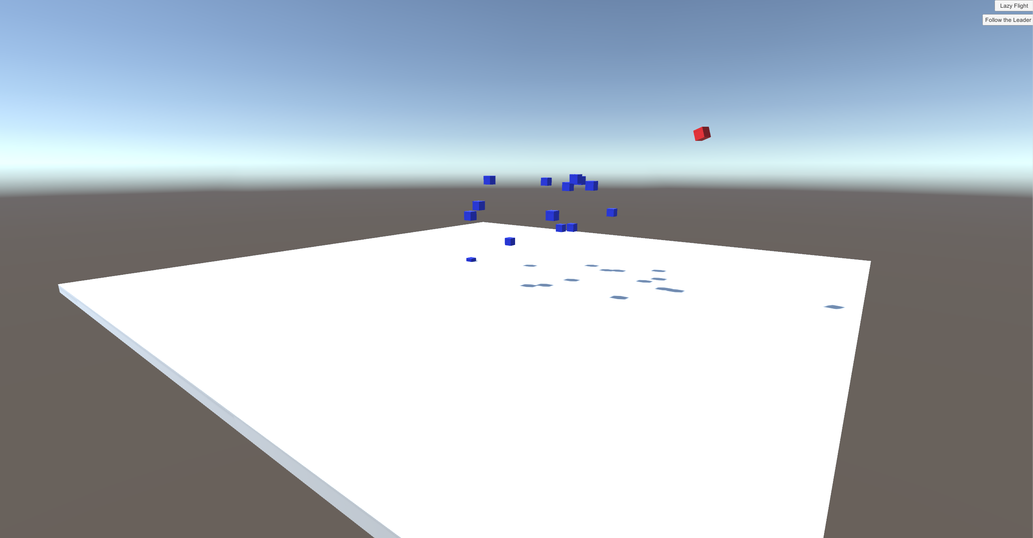

***‘YOU CAN WATCH CUBES FLY, WOWW’*** - Manuel Perez

This page: Table of Contents and Team Member Listing

|  |  |
| --- | --- |
| Table of Contents  [1 Game Overview](https://n-xovwktmtjsnaxyc2mwes2xu7pohqedmdm6zjw5q-2lu-script.googleusercontent.com/userCodeAppPanel%23)  [2 High Concept](https://n-xovwktmtjsnaxyc2mwes2xu7pohqedmdm6zjw5q-2lu-script.googleusercontent.com/userCodeAppPanel%23)  [3 Unique Selling Points](https://n-xovwktmtjsnaxyc2mwes2xu7pohqedmdm6zjw5q-2lu-script.googleusercontent.com/userCodeAppPanel%23)  [4 Platform Minimum Requirements](https://n-xovwktmtjsnaxyc2mwes2xu7pohqedmdm6zjw5q-2lu-script.googleusercontent.com/userCodeAppPanel%23)  [5 Competitors / Similar Titles](https://n-xovwktmtjsnaxyc2mwes2xu7pohqedmdm6zjw5q-2lu-script.googleusercontent.com/userCodeAppPanel%23)  [6 Synopsis](https://n-xovwktmtjsnaxyc2mwes2xu7pohqedmdm6zjw5q-2lu-script.googleusercontent.com/userCodeAppPanel%23)  [7 Game Objectives](https://n-xovwktmtjsnaxyc2mwes2xu7pohqedmdm6zjw5q-2lu-script.googleusercontent.com/userCodeAppPanel%23)  [8 Game Rules](https://n-xovwktmtjsnaxyc2mwes2xu7pohqedmdm6zjw5q-2lu-script.googleusercontent.com/userCodeAppPanel%23)  [9 Game Structure](https://n-xovwktmtjsnaxyc2mwes2xu7pohqedmdm6zjw5q-2lu-script.googleusercontent.com/userCodeAppPanel%23)  [10 Game Play](https://n-xovwktmtjsnaxyc2mwes2xu7pohqedmdm6zjw5q-2lu-script.googleusercontent.com/userCodeAppPanel%23)  [10.1 Game Controls](https://n-xovwktmtjsnaxyc2mwes2xu7pohqedmdm6zjw5q-2lu-script.googleusercontent.com/userCodeAppPanel%23)  [10.2 Game Camera](https://n-xovwktmtjsnaxyc2mwes2xu7pohqedmdm6zjw5q-2lu-script.googleusercontent.com/userCodeAppPanel%23)  [10.2.1 HUD](https://n-xovwktmtjsnaxyc2mwes2xu7pohqedmdm6zjw5q-2lu-script.googleusercontent.com/userCodeAppPanel%23)  [10.2.2 Maps](https://n-xovwktmtjsnaxyc2mwes2xu7pohqedmdm6zjw5q-2lu-script.googleusercontent.com/userCodeAppPanel%23)  [11 Players](https://n-xovwktmtjsnaxyc2mwes2xu7pohqedmdm6zjw5q-2lu-script.googleusercontent.com/userCodeAppPanel%23)  [11.1 Characters](https://n-xovwktmtjsnaxyc2mwes2xu7pohqedmdm6zjw5q-2lu-script.googleusercontent.com/userCodeAppPanel%23)  [11.2 Metrics](https://n-xovwktmtjsnaxyc2mwes2xu7pohqedmdm6zjw5q-2lu-script.googleusercontent.com/userCodeAppPanel%23)  [11.3 States](https://n-xovwktmtjsnaxyc2mwes2xu7pohqedmdm6zjw5q-2lu-script.googleusercontent.com/userCodeAppPanel%23)  [11.4 Weapons](https://n-xovwktmtjsnaxyc2mwes2xu7pohqedmdm6zjw5q-2lu-script.googleusercontent.com/userCodeAppPanel%23)  [12 Player Line-up](https://n-xovwktmtjsnaxyc2mwes2xu7pohqedmdm6zjw5q-2lu-script.googleusercontent.com/userCodeAppPanel%23)  [13 NPC](https://n-xovwktmtjsnaxyc2mwes2xu7pohqedmdm6zjw5q-2lu-script.googleusercontent.com/userCodeAppPanel%23)  [13.1 Enemies](https://n-xovwktmtjsnaxyc2mwes2xu7pohqedmdm6zjw5q-2lu-script.googleusercontent.com/userCodeAppPanel%23)  [13.1.1 Enemy States](https://n-xovwktmtjsnaxyc2mwes2xu7pohqedmdm6zjw5q-2lu-script.googleusercontent.com/userCodeAppPanel%23)  [13.1.2 Enemy Spawn Points](https://n-xovwktmtjsnaxyc2mwes2xu7pohqedmdm6zjw5q-2lu-script.googleusercontent.com/userCodeAppPanel%23)  [13.2 Allies / Companions](https://n-xovwktmtjsnaxyc2mwes2xu7pohqedmdm6zjw5q-2lu-script.googleusercontent.com/userCodeAppPanel%23)  [13.2.1 Ally States](https://n-xovwktmtjsnaxyc2mwes2xu7pohqedmdm6zjw5q-2lu-script.googleusercontent.com/userCodeAppPanel%23)  [13.2.2 Ally Spawn Points](https://n-xovwktmtjsnaxyc2mwes2xu7pohqedmdm6zjw5q-2lu-script.googleusercontent.com/userCodeAppPanel%23)  [14 Art](https://n-xovwktmtjsnaxyc2mwes2xu7pohqedmdm6zjw5q-2lu-script.googleusercontent.com/userCodeAppPanel%23)  [14.1 Setting](https://n-xovwktmtjsnaxyc2mwes2xu7pohqedmdm6zjw5q-2lu-script.googleusercontent.com/userCodeAppPanel%23)  [14.2 Level Design](https://n-xovwktmtjsnaxyc2mwes2xu7pohqedmdm6zjw5q-2lu-script.googleusercontent.com/userCodeAppPanel%23)  [14.3 Audio](https://n-xovwktmtjsnaxyc2mwes2xu7pohqedmdm6zjw5q-2lu-script.googleusercontent.com/userCodeAppPanel%23)  [15 Procedurally Generated Content](https://n-xovwktmtjsnaxyc2mwes2xu7pohqedmdm6zjw5q-2lu-script.googleusercontent.com/userCodeAppPanel%23)  [15.1 Environment](https://n-xovwktmtjsnaxyc2mwes2xu7pohqedmdm6zjw5q-2lu-script.googleusercontent.com/userCodeAppPanel%23)  [15.2 Levels](https://n-xovwktmtjsnaxyc2mwes2xu7pohqedmdm6zjw5q-2lu-script.googleusercontent.com/userCodeAppPanel%23)  [15.3 Artificial Intelligence NPC](https://n-xovwktmtjsnaxyc2mwes2xu7pohqedmdm6zjw5q-2lu-script.googleusercontent.com/userCodeAppPanel%23)  [15.4 Visual Arts](https://n-xovwktmtjsnaxyc2mwes2xu7pohqedmdm6zjw5q-2lu-script.googleusercontent.com/userCodeAppPanel%23)  [15.5 Audio](https://n-xovwktmtjsnaxyc2mwes2xu7pohqedmdm6zjw5q-2lu-script.googleusercontent.com/userCodeAppPanel%23)  [15.6 Minimum Viable Product (MPV)](https://n-xovwktmtjsnaxyc2mwes2xu7pohqedmdm6zjw5q-2lu-script.googleusercontent.com/userCodeAppPanel%23)  [16 Wish List](https://n-xovwktmtjsnaxyc2mwes2xu7pohqedmdm6zjw5q-2lu-script.googleusercontent.com/userCodeAppPanel%23) | Game Development Team Members    PRODUCER  Manuel Perez    PRODUCTION MANAGER  Manuel Perez    PRODUCTION COORDINATOR  Manuel Perez  GAME DESIGNERS  Manuel Perez  SYSTEMS/IT COORDINATOR  Manuel Perez  PROGRAMMERS  Manuel Perez  TECHNICAL ARTISTS  Manuel Perez  AUDIO ENGINEERS  Manuel Perez  UX TESTERS  Manuel Perez |

|  |
| --- |
|  |

# 1 Game Overview

Title: AI Boids (Project 2)

Platform: PC Standalone

Genre: Simulation

Rating: (99+) ESRB

Target: Expert gamers (aging from 23 - 66)

Release date: April, 2020

Publisher: Manuel Games

Description: This game is a simulation that showcases several AI boids as they either float around the environment or follow a specific target colored in red.

# 2 High Concept

A game simulation showcasing different types of AI patterns.

# 3 Unique Selling Points

Probably a good time if you like looking at things move.

# 4 Platform Minimum Requirements

Processor: 2.7 GHz Dual-Core Intel Core i5

Memory: 8 GB 1867 MHz DDR3

Graphics: Intel Iris Graphics 6100 1536 MB

# 5 Competitors / Similar Titles

Farming Simulator

# 6 Synopsis

You are a lonely bystander looking at cubes flying in different patterns.

# 7 Game Objectives

Look at the cubes move.

# 8 Game Rules

The only rule is that there is no rules.

# 9 Game Structure

The simulator presents you with two options: Lazy Flight, and Follow the Leader.

# 10 Game Play

You can press two buttons that allow you to see different flocking modes.

## 10.1 Game Controls

You can use your mouse to click around.

## 10.2 Game Camera

It’s a stationary camera that does not move.

### 10.2.1 HUD

### 10.2.2 Maps

N/A

# 11 Players

N/A

## 11.1 Characters

N/A

## 11.2 Metrics

N/A

## 11.3 States

N/A

## 11.4 Weapons

N/A

# 12 Player Line-up

N/A

# 13 NPC

## 13.1 Enemies

N/A

### 13.1.1 Enemy States

N/A

### 13.1.2 Enemy Spawn Points

N/A

## 13.2 Allies / Companions

A target. A boid.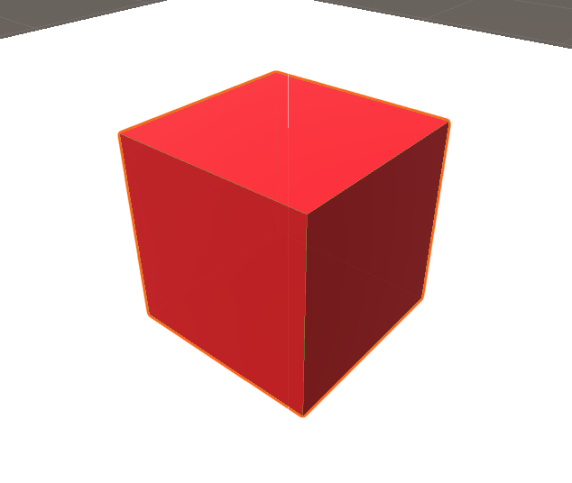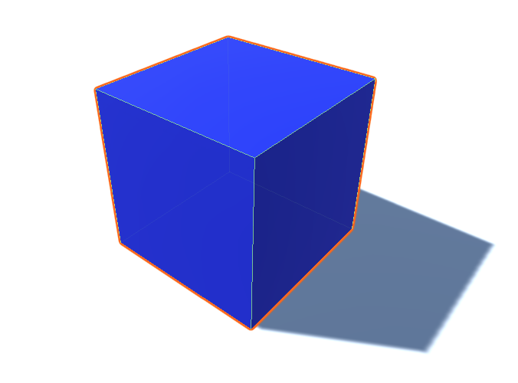

### 13.2.1 Ally States

N/A

### 13.2.2 Ally Spawn Points

N/A

# 14 Art

## 14.1 Setting

A simple floor.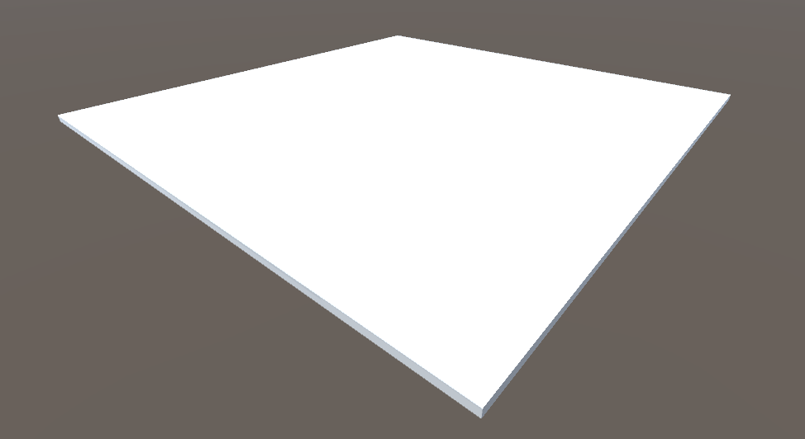

## 14.2 Level Design

Again just a simple floor.

## 14.3 Audio

N/A

# 15 Procedurally Generated Content

## 15.1 Environment

The same floor.

## 15.2 Levels

N/A

## 15.3 Artificial Intelligence NPC

N/A

## 15.4 Visual Arts

N/A

## 15.5 Audio

N/A

## 15.6 Minimum Viable Product (MPV)

N/A

# 16 Wish List

I wish I had added the circular tree target mode.

I wish the boids did not stick to each other after some time of flying around.